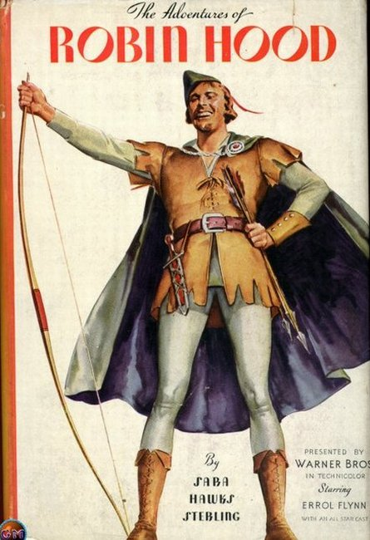

This is our way of saying Thank You for a wonderful 2005.This is **NOT** a workshop or seminar...just a movie and a FUN DAY for the family. So mark your calendars, SAVE the DATE and come out and enjoy your grandkids with a good movie and Free popcorn and drinks!!!

Grandkids or No Grandkids…All are Welcome!

*A movie that won’t make you or the grandkids blush!*

*When*

*movies were movies!*

GRANDPARENTS

Grab your Grandkids!

**Free Movie!**

**Free**

**Unlimited Popcorn and Drinks!**

**A Bag of Chocolate Gold Coins for all the kids!**

**GRANDPARENTS** grab your **Grandkids**

Please join us for a **FREE** private screening of

**[“The Adventures of Robin Hood”]**

*[Starring Errol Flynn and Olivia de Havilland]*

When: [Day, Month 00th]

Where: [Theater Name], [Location]   
Time: [0:00 pm]

**RSVP Required: Call [000-0000] by [Month 00]**

Sponsored by:   
[Advisor’s Name and Company Name]

**Come out and enjoy an afternoon at the movies with the grandkids!**